IRDC LAB REPORT

DATE: 31-05-2021

TO:

**Subject:** Report About the Condition of the IRDC Labs

We, Hind Mohammed and Zakareya Hussein, the lab assistances in the IRDC building writing this letter to you to inform that, since we officially started working on March 20, we did not receive any report on the building's holdings, we did not find inside the laboratories any documents indicating the number and dates of installing all devices, including projectors and air conditioning.

But we continued to work with Dr. Jennifer and under her supervision and we made special reports for computers only, and we used to operate the air conditioning through Dr. Jennifer’s phone only, we don’t have any **conditioner remote**, and when Dr. Jennifer went, we had difficulty working in the building without air conditioning and that because of the high temperature, which affects the devices and may cause damage, and also on us working. In addition to the lack of necessary safety equipment, such as fire extinguishers, which are necessary in a building full of electrical devices.

One is to know the locations of all the holdings, and we still have some non-installed parts that need to be connected with regard to the laboratories and the iOS lab, which is very important, is incomplete and the devices are not connected and the sockets in it are not compatible with the devices, and we add Also, there is no availability of the least work components, we consider those as a necessity to the building to provide a good work environment for working and good studying environment for the student:

* **Conditioner, projectors remote** we need more than one to provide efficiency
* **Water cooler**, as we worked for two months or more and we still did not obtain one.
* **Curtains in the laboratories** and it is very important because it keeps the devices from dust that severely affects the devices and may cause damage.

We want it to work in the fullest way, but the work environment now is not a suitable for working, and not safe for the devices with temperatures is getting higher up to 42C0 degree.

So, we present this report and it contains all the problems that we are facing now and we hope you look in order to be able to restore the work to its natural form, thank you.

**Best Regards.**

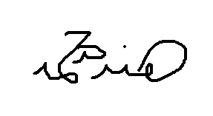Lab Assistance: Hinda Mohammed

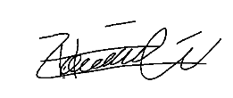Lab Assistance: Zakareya Hussein